How to Handle Your Report.
Chances are that you feel very protective about your work. This is your child, and you have raised it single-handedly. Below, in a few more lines, some very nasty people are probably going to say some very unkind things about your baby.

It is very unlikely that the report which follows is going to make you feel happy at all, not initially.

It is important that you understand that your novel is no longer your child. Your novel is an adult who has gone out into the world on its own. In the real world, it doesn’t really matter much that your mother loves you. What matters is whether other people even like you, let alone love you.

All novels are riddled with faults. MOBY DICK, THE SOUND AND THE FURY and LES MISERABLES are all deeply flawed. For everyone who thinks a novel is a work of genius, there are hundreds more who find it boring, irrelevant and a waste of paper.

The process of revising a manuscript is a slow one. There are two things which you should not do with regard to this report. You should not immediately begin to slash and burn your work like so much underbrush. Nor should do whatever the electronic equivalent is of screwing up this report and throwing it in the bin.

When you read the report, there is a pretty strong chance that your hair will stand on end. And when you re-read your work, it will turn to ashes in your mouth. It is very traumatic to look at your own work after an impartial person has put in her two cents’ worth. It might be only two cents’ worth of medicine, but it is your medicine, and you have to take it. Provide your own sugar and spoon.

If something is worth doing, it is worth doing well. You need to read the report at least five times and wait at least a week before you even consider making changes to your work. Great writing, even good writing, is achieved through many hours of careful thought and hard work.

In an ideal world, you will consider all our advice carefully. And you will assert your authorial authority and discard most of it.

The purpose of this report is to make you read your work more objectively; to help you see your work as others see it.

You wrote this thing for your readers, not for yourself. It is the opinion of the reader which really matters.

Go slowly. Think a lot. There is plenty of time. Easy does it.

Your quotes are in blue
Our alternative versions are red
The opening of CALIFACTIONS is certainly promising: Johnny Ray, a blind homeless war veteran finds himself miraculously healed in a San Francisco park. Cut to Tommy Delacroix, alternative journalist turned high tech company copy writer who previously befriended Johnny and is now his first port of call when he is picked up by the police following his miracle encounter with a Jesus-like figure.

The first thing that stands out here is the shift in style, from Johnny’s perspective - rich, almost dream-like prose - to Tommy’s, which is far more spare and ‘realist’. This works well, and in terms of plot, you manage to build up tension surrounding Johnny’s miraculous healing and the identity of his ‘saviour’. Then, however, the story shifts to local politics and, more specifically, politics of the late nineties, and this is where some of the novel’s problems arise.

Setting
In itself, setting your story in 1998 San Francisco at the height of the dotcom boom is not a problem. But when you go into great detail outlining local politics, you lose a lot of your narrative drive and, I fear, quite a few of your readers:

"Mr. Garfield from the Mayor's campaign called. He plans to move the announcement up to the first and wants to know if everyone can be on board that soon?"

The Mayor was planning a run for the Senate in 2000, which meant facing down the popular incumbent in a primary election. Though widely anticipated by the press and the public alike, no official announcement had been made. Yet. Mr. Claibourne had been charged with lining up endorsements and donations from select business and political groups in San Francisco, Santa Clara, Sacramento, and everywhere in between.

This is just one example of many. You seem to write about what you know, which is a good thing, but by going into too much detail you run the risk of becoming too parochial, and of boring your readers. It might be a good idea to set your novel in another US city in order to force yourself to generalise and get rid of the ‘self’. Use your imagination. If you insist on San Francisco as the setting, cut down on the details and add some local colour instead. You already do this very well in places. Here’s an example:

On the sidewalk, Tommy dodged the parade of the previous night's catch. Prostitutes with crooked wigs, gangbangers with bloody jackets and low-slung pants, bleary-eyed party boys in black street shoes and silk bowling shirts, followed closely by their lawyers or grandmothers or girlfriends, who were grim and quiet and seething with so much disappointment Tommy could almost smell it. Some of the guys wore bad boy smirks infused with their bad boy escapades. They sniggered and knocked each other's shoulders like school kids sent to the principal's office.

Inside the lobby, a cacophony of ringing cell phones and static-y radios bounced off the marble and wrapped around the shouts of lawyers and cops. A sinus-clearing bouquet of lemon-pine industrial cleaner punctured the air.

Tommy blinked, his eyes adjusting to the inadequate light. Someone tapped his shoulder. He turned around to face a big Italian cop, a wall of black uniform and jangling chains. Guardino smiled through a groomed mustache, the ends waxed into points.’

‘Bad boy smirks infused with their bad boy escapades’ may be somewhat redundant, but overall, you paint a vivid picture here.

Style
I have no problem with your style overall, but I would like to see more of the aforementioned rich prose when you tell the story from Johnny’s point of view. Occasionally, you use an overwrought metaphor such as ‘fingertips pressed together like a skeletal church’ where ‘steepled fingers’ would have done the trick, a slightly clichéd phrase like ‘a fear she couldn’t name’, or ‘He wept and the car trembled with his weeping’, but these are minor quibbles.

Genre
It occurs to me that CALIFACTIONS would have greater potential if you stepped up the satire. There are some echoes of the bestselling (if flawed) THIS BOOK WILL CHANGE YOUR LIFE by AM Homes, but I want to see more humour, more sentences like these:

The NAHA never amounted to anything more than five people in an office in Esparto, not counting Chief Mark Hawk. Chief Mark was a stock character actor recognizable from his roles in F Troop and virtually every Hollywood Western produced since 1965.

and:

Tommy doubted that angels, let alone Jesus, went in for monogrammed robes.

(The latter reminds me of Philip Roth’s PORTNOY’S COMPLAINT, where, upon visiting a Catholic friend at his New Jersey home, the narrator describes a picture of Jesus in the kitchen as ‘wearing a gown that I realize today must have come from Fredericks of Hollywood’). Really, don’t be afraid to go a step or ten further.

Show, Don’t Tell
This ties in with characterisation. Consider the introduction of Mr Claibourne:

The whole office was paneled in the original blonde wood, panels which concealed a wet bar that hadn't been opened since Mr. Claibourne Senior had retired for health reasons ten years before.

Mr. Claibourne's desk, the same desk his father had used before him, faced the room at a perfect diagonal from the hub of the L. Indeed, when Mr. Claibourne Junior took over, he'd changed nothing, not the furniture, not the framed illustrations of San Francisco, and certainly not the formalities of using Mr. and Ms. when addressing each other.

Almost nothing. He did remove the antique glass domed stock ticker from the corner behind the desk. ( I always hated this thing, Marta heard him say to no one as he dragged it out of the way.) In its place he'd set a large potted ficus whose leaves and branches had, in the ten years since, grown into a massive gray-green cloud that loomed over the desk chair.

This morning, the tree was struck into bright emerald by the sunlight slanting in from the Montgomery Street windows. That corner always had good light, Marta thought as she came in. She could still remember how the sun had struck the brass workings of the stock ticker.

The reader is not particularly interested in the way the office has changed (or not, as the case may be) or the potted plants – unless there is a valid reason. If, for instance, you were to write a novel set on Wall Street in the 1980s, a description of conspicuous consumption would be appropriate (and let’s face it, Bret Easton Ellis made a fortune out of it), but it adds little here. I want to see that Claibourne is a corporate prick, and his secretary Marta a far more sympathetic, if somewhat downtrodden, character, but you follow a lengthy description of his office and her family life with a fairly brief exchange between the two. I think it would have been more effective to have started off with their conversation and then woven some background into it.

Textual Analysis
It is my standard practice to do some textual analysis and to pick out the significant words. These significant words often give great insight into what is ‘really’ going on in the work. The real ‘theme’ often emerges.

The top ten significant words I can find in this section of CALIFACTIONS:

- Bagel (13)
- Blind (12) – yes, I know this a name in your context.
- Dog (13) - ditto
- Lean(ed) (12)
- Meeting (11)
- Neighborhood (8)
- Office (12)
- Pie (9)
- Press (11)
- Voice (11)

Perhaps you need to think a little about the amount of leaning and bagel eating going on. I can’t find any significant repeated phrases of more than two words. In short, this is very clean writing.

Some people like word clouds and find them both useful and interesting; for others they are a waste of time. At the end of this document you will find the word cloud of R.L.Stevenson’s TREASURE ISLAND, for comparison.
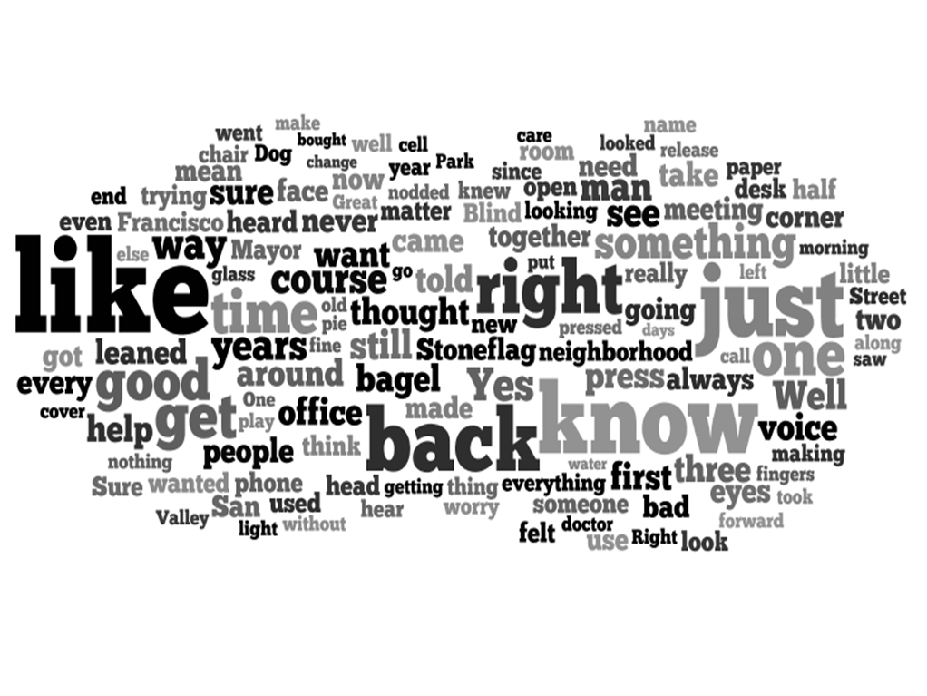
http://www.wordle.net

This word cloud has the names of the characters stripped out, though Stoneflag remains. Believe me, there were an awful lot of names! You can see how like, just, know and back dominate. Obviously, you don’t want to (and can’t) work too hard on these kinds of words but the MS would probably benefit from the elimination of a couple examples of each.

Nit Picking
I have picked out five sentences, just to look at them wholly out of context and in isolation. I promise you that these five sentences are altogether random.

Marta occupied the cottage in the back, where she could watch the boys play outside her window.
‘Occupied’ sounds temporary.
Do you mean ‘in the back’ or ‘at the back’?

Tommy wondered about Blind Johnny Ray.
I generally find ‘wondered’ to be a weak verb, and you use it six times.

The next year, right after Thanksgiving, Johnny stopped Tommy on the corner and, touching his wrist as lightly as a butterfly, asked if he could help him wrap and send the presents again.
I like this sentence a lot, but if I were nit-picking (which I am) I might question a butterfly metaphor for events occurring in November. I might also argue that Thanksgiving is already a metaphor…

She was very well paid and had flexible hours--some days she hardly worked at all, just covering Mr. Claibourne's private messages from home--with the understanding that when the time came to push, her shoulder would be right up against the wheel with his.
She was very well paid and had flexible hours. Some days she hardly worked at all, covering Mr. Claibourne's private messages from home, with the understanding that when the time came to push, her shoulder would be right up against the wheel with his.

Tommy thought that might be code, meaning Johnny was high on something.
Does Johnny use code when he is high, or is he saying, “I am high,” in code?

Summary
There is no doubt that there is some real talent here. I want to find out what really happened to Johnny Ray, how Tommy gets to the bottom of it, and whether he manages not to sell his soul. However, the story needs to pack more of a punch. It needs to be darker, more satirical. There is also the obvious problem of topicality – the world has moved on since the dotcom boom, and novels set during the credit crunch have taken over. If you want to stand out in this market you might want to reconsider the setting, but either way I would like to see a bit more passion here.

- Consider changing the setting to another time and place.
- Beware of overwrought metaphors
- Show us more of Claiborne’s awfulness
- Up the satire
- Eat fewer bagels

Advice about Advice
There is no point in getting worked up about advice which you don’t like. If you don’t like the advice we have given, don’t take it. There is a vast variety and range of tastes in the world, but almost no one likes bad writing. If you feel it is important to describe the hair styles, or whatever, of your characters in great detail, go right ahead, but before you do, at least consider the alternatives. Rejecting advice is just as important as accepting it.
- TREASURE ISLAND Word Cloud, for comparison.

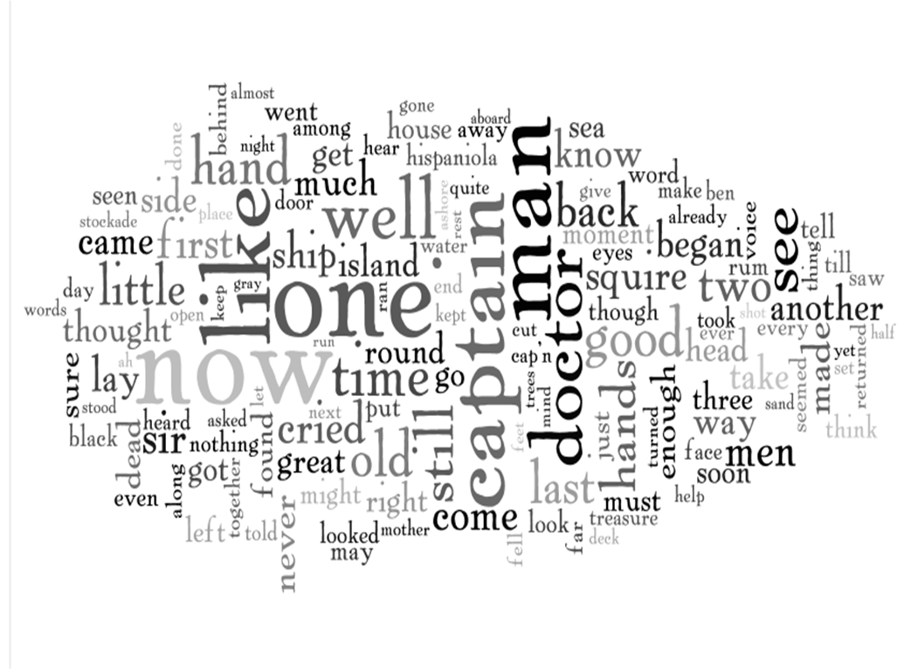http://www.wordle.net

