How to Handle Your Report.
Chances are that you feel very protective about your work. This is your child, and you have raised it single-handedly. Below, in a few more lines, some very nasty people are probably going to say some very unkind things about your baby.

It is very unlikely that the report which follows is going to make you feel happy at all, not initially.

It is important that you understand that your novel is no longer your child. Your novel is an adult who has gone out into the world on its own. In the real world, it doesn’t really matter much that your mother loves you. What matters is whether other people even like you, let alone love you.

All novels are riddled with faults. MOBY DICK, THE SOUND AND THE FURY and LES MISERABLES are all deeply flawed. For everyone who thinks a novel is a work of genius, there are hundreds more who find it boring, irrelevant and a waste of paper.

The process of revising a manuscript is a slow one. There are two things which you should not do with regard to this report. You should not immediately begin to slash and burn your work like so much underbrush. Nor should do whatever the electronic equivalent is of screwing up this report and throwing it in the bin.

When you read the report, there is a pretty strong chance that your hair will stand on end. And when you re-read your work, it will turn to ashes in your mouth. It is very traumatic to look at your own work after an impartial person has put in her two cents’ worth. It might be only two cents’ worth of medicine, but it is your medicine, and you have to take it. Provide your own sugar and spoon.

If something is worth doing, it is worth doing well. You need to read the report at least five times and wait at least a week before you even consider making changes to your work. Great writing, even good writing, is achieved through many hours of careful thought and hard work.

In an ideal world, you will consider all our advice carefully. And you will assert your authorial authority and discard most of it.

The purpose of this report is to make you read your work more objectively; to help you see your work as others see it.

You wrote this thing for your readers, not for yourself. It is the opinion of the reader which really matters.

Go slowly. Think a lot. There is plenty of time. Easy does it.
Your quotes are in blue
Our alternative versions are red
I suppose you might consider this unfair, but there is, as you are doubtless all too well aware, one problem with CURSED IN FIRE which transcends and surpasses all others: you can’t write in English. And you are not a close confidante of Ford Maddox Ford. As far as I am concerned CURSED IN FIRE is unpublishable, and verging on unreadable. I am not going to go through manuscript picking your ‘mistakes’ out one by one because they are legion and because some of them are very subtle, but I find it very hard to locate even one ‘perfect’ sentence.

Joseph Conrad and Vladimir Nabokov were neither native speakers of English (one could further contend that neither was Chaucer, nor Shakespeare) but they became two of the finest stylists my language has ever known. They achieved this by having very good friends, and by writing very good books. Conrad did everything in his power to mimic the style of writers he admired; Nabokov arrogantly blasted away with the Gatling gun of his own conceit. I am not your friend. CURSED IN FIRE is not PNIN.

As I see it, there are three alternative ways forward for CURSED IN FIRE.

- Conrad route: You need a Ford Maddox Ford: an extremely accomplished wordsmith in his own right who is prepared to munch through this manuscript sentence by sentence picking out every single glitch of vocabulary or phraseology and waving them in front of your increasingly disgruntled face.
- Nabokov route: your extremely curious but insufficiently ambitious style and vocabulary need to be put under control, magnified, emphasised and squeezed till its stony blood runs.
- Russel Hoban route: read Ridley Walker. Posit CURSED IN FIRE as an historical document. Convert your English into a deliberately archaic future-speak; not exactly an ideologue, but more of an ideo-argot. You are halfway down this road already.

You will certainly not be able to follow route 1. CURSED IN FIRE is not good enough, by any standards, nor is it sufficiently promising for anyone with any skill or craft to work through it as necessary. It is too much work. You can’t afford it.

Route 2 is interesting from my point of view, in that I prefer reviewing ambitious works, and may be the most interesting from your own point of view. Attempt to execute an arrogant, stylistic masterpiece with no rulebook involved. It is very unlikely that you will turn out to be one of the greatest stylists and most accomplished minds in the history of literature, but if you have read THE EYE, WATCH AND WARD or GRIMUS there were times when the same could have been said of Nabokov, James or Rushdie. It still is true of Rushdie. Accept your limitations, don’t try to be normal: rage.

Route 3 is by far the easiest for you to pull off.

And now so chronicalizer I am as time longlyby time days of MOLACH amang MERICANISTS, and so they die. 4 alday rember well 4 gain it shall come, as always did and always willy-nilly.

Blah, blah, blah. Let rip with your enormous vocabulary. Muddle Hebrew with English. Throw everything into the pot. Write biblically. It still won’t work; it will still be unpublishable, but it will be a work of some kind of art, and something you can be proud of, or likewise despise. Set the whole novel in Hell from the point of view of a fallen recording angel. Consider Roberston Davies’ attempts at similar ideas. Inject humour.

You are not just competing with Clive Barker here. You need to consider BLOOD MERIDIAN and maybe even BELOVED. There is no point in aspiring to be a third rate Clive Barker. Clive Barker is already second rate.

You cannot clean this up on your own. No one is going to help you. Get a bit crazy. Only madness can save you now. Turn your biggest problem into your best feature.

Dialogue
I have no idea what you are trying to achieve by the dreadful attempt at vernacular in the first chapter. Is this man Irish? Is he just stupid? Is he Walter Huston after his third stroke? Is he Scottish? He sounds like a Serbian who rocked up stateside about 5 years ago and has learned all his English from UNCLE REMUS and Oklahoma. It is pointless and dreadful. It has annoyed everyone who read it, and amused no one. Cut it out. Your attempts to describe the scene are already difficult enough without overcomplicating things.

Too Many ‘Descriptive Words’
I notice that you use plain, simple language, short words and brief sentences. That is the way to write English - it is the modern way and the best way. Stick to it; don't let fluff and flowers and verbosity creep in. When you catch an adjective, kill it. No, I don't mean utterly, but kill most of them - then the rest will be valuable. They weaken when they are close together. They give strength when they are wide apart. An adjective habit, or a wordy, diffuse, flowery habit, once fastened upon a person, is as hard to get rid of as any other vice.
- Mark Twain in a Letter to D. W. Bowser, 3/20/1880

It is a standard writing exercise to pick through something your consider ‘finished’ and remove all the adverbs and adjectives: to minimise. While CURSED IN FIRE perhaps needs the language embellished and made even more obscure, intricate and florid, you should still consider every single word in the text. I am going to do this for you in one section:

And her blungeoned body, with the signs of a cruel punishment on the red of the hair, was found crumbled and discarded the next morning. Five women in all were recorded as victims of this inhumane killer, perhaps others. No plausible reason for the heinous crimes; no clues to the identity of the cruel murderer were in evidence.

And her body, with the signs of punishment on the red of the hair, was found the next morning. Five women were recorded victims of the killer; perhaps there had been others. No reason for the crimes, no clues to the identity of the murderer were in evidence.

There is a world of difference between yours and mine. Focus on that difference. You want to think about how you need to change my version to make it say what you were trying to say in yours. I have disregarded the many ‘errors’ in your sentences, and worked purely on style.

Can you honestly read this sentence and think it is ‘good’?

A final curse from his fleshy lips was flung at the beaten and bloody corpse as the stalker turned and walked away; the sound of his weighty footfalls slowly diminished in the still passages of the night.

You should think it is good: you worked hard enough at it.

A curse came from his lips as he turned and walked away, his footfalls diminishing into the night.

I am not saying that my sentences are better than yours. I am saying that my sentence does the job. If you NEED more, then add more. Add the minimum.

Preamble
The Vincent Price voice over at the beginning does not amuse me, and will not amuse any publishers. CURSED IN FIRE will never be published while this letter to your reader remains. No one will read beyond it. On reading it, I honestly thought I was about to be confronted by a Rocky Horror Picture Show spoof, or a children’s story after Michael Jackson’s Thriller. It made me laugh out loud.

The long historical details of the origins of the curse or cult are boring and unnecessary. Let your story stand for itself and get straight into it. Remove the Dear Readers section completely and if you really feel your historical ramblings are necessary, move them to an appendix and put them at the end.

Spelling
I am asking myself exactly what it means to have been submitted a manuscript that has not been spell checked, and I am not finding any pleasing answers.

Textual Analysis
It is my standard practice to do some textual analysis and to pick out the significant words. These significant words often give great insight into what is ‘really’ going on in the work. The real ‘theme’ often emerges.

The top ten significant word families I can find in this section of CURSED IN FIRE are:
- Body (29)
- Damn (22)
- Fear (29)
- Good (40)
- Night (42)
- Sacrifice (32)
- Shadow (29)
- Spirit (30)
- Through (50)
- Word (48)

All of these words are grossly overused. Normally, I am extremely Thesaurus averse, but in this kind of work, where vocabulary and word games (spells, prayers and incantations) play a major part, you urgently need to sharpen things up. Readers of this kind of work enjoy and expect obscure lexical items. CURSED IN FIRE would greatly benefit from a reduction of at least 50% in each of these words.

Some people like word clouds and find them both useful and interesting; for others they are a waste of time. At the end of this document you will find the word cloud of R.L.Stevenson’s TREASURE ISLAND, for comparison.

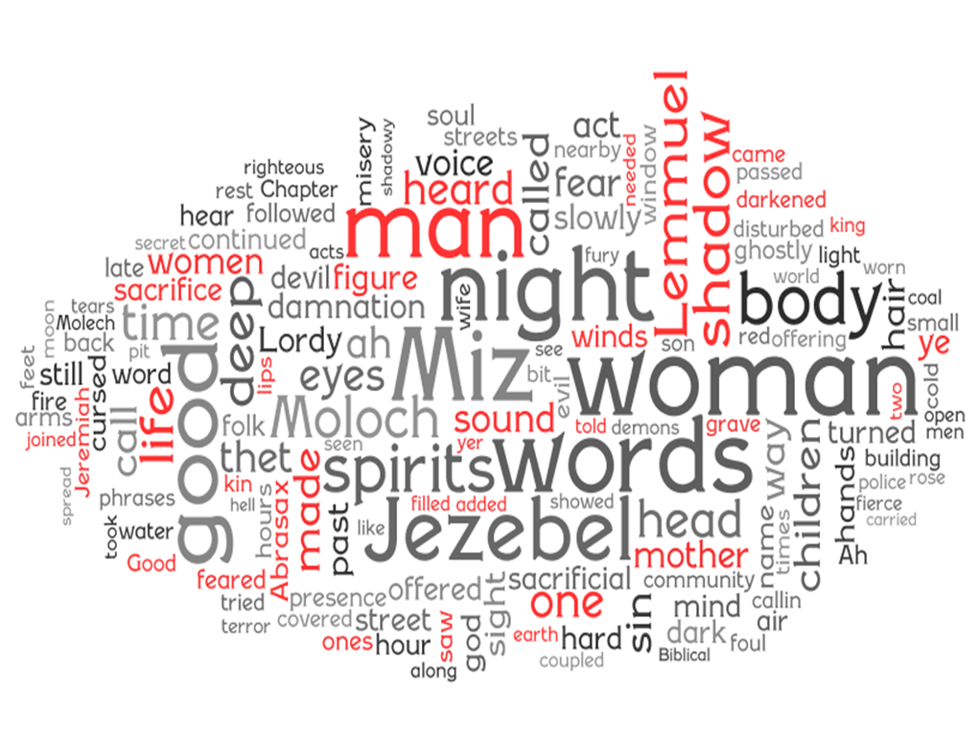
http://www.wordle.net

I find this Word Cloud particularly pleasing. It does actually capture the feel of your work. You do need to question the prominence of man and woman. Was that your intention?

Nit Picking
I have picked out five sentences, just to look at them out of context or in isolation. I promise you that these five sentences are wholly random.

Quickly she lowered her garment and stared at the angry ghost.
Quickly, she lowered her garment and stared at the angry ghost.

Only his back with thet bloody stick in his hand goin' up an' down whackin' agin' an' agin' on thet por' woman's head.
It isn’t just fake, it is badly done fake. I have no idea why you are doing this.

The routine of the evening life continued with the man of the house plunging into his favourite armchair.
This is OK actually. I quite liked the scenes of ordinary life going on, but they are a bit stereotyped and cumbersome. Is it really interesting? What you are really saying here is：
The man sat in a chair.

Through their cunning eyes they saw the coming of the damnation of the hunt that will bring the chosen one to the fiery pit of sacrifice.
This sentence is wholly and completely without any merit whatsoever.

The good folk took heart to the warning words of the believers and took caution if they needed to tred through the woods in the darkness of the night.
See comment on previous sentence.

Summary
CURSED IN FIRE is in great need of repair. You will never be able to make a conventional novel out of it and need to overhaul the style of the piece, even if you just want to make it into something you can be proud of.

- Get crazier and more ambitious. Abandon conventional sentence structure and the rules of grammar.
- Ditch the phony dialogue.
- The route forward is not the addition of even more adverbs and adjectives.
- Add some humour. The devil is a really funny guy.
- Remove all the preamble and get straight into the story.
- Jezebel?

Advice about Advice
There is no point in getting worked up about advice which you don’t like. If you don’t like the advice we have given, don’t take it. There is a vast variety and range of tastes in the world, but almost no one likes bad writing. If you feel it is important to describe the hair styles, or whatever, of your characters in great detail, go right ahead, but before you do, at least consider the alternatives. Rejecting advice is just as important as accepting it.

TREASURE ISLAND Word Cloud, for comparison.
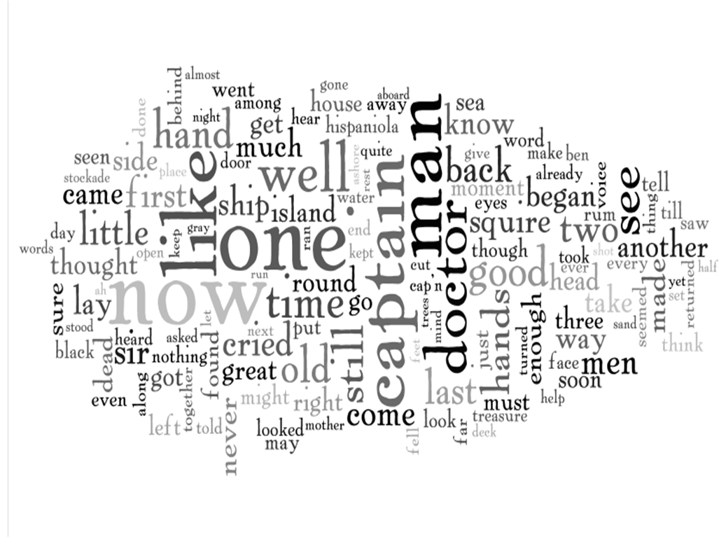http://www.wordle.net

