How to Handle Your Report.
Chances are that you feel very protective about your work. This is your child, and you have raised it single-handedly. Below, in a few more lines, some very nasty people are probably going to say some very unkind things about your baby.

It is very unlikely that the report which follows is going to make you feel happy at all, not initially.

It is important that you understand that your novel is no longer your child. Your novel is an adult who has gone out into the world on its own. In the real world, it doesn’t really matter much that your mother loves you. What matters is whether other people even like you, let alone love you.

All novels are riddled with faults. MOBY DICK, THE SOUND AND THE FURY and LES MISERABLES are all deeply flawed. For everyone who thinks a novel is a work of genius, there are hundreds more who find it boring, irrelevant and a waste of paper.

The process of revising a manuscript is a slow one. There are two things which you should not do with regard to this report. You should not immediately begin to slash and burn your work like so much underbrush. Nor should do whatever the electronic equivalent is of screwing up this report and throwing it in the bin.

When you read the report, there is pretty strong chance that your hair will stand on end. And when you re-read your work, it will turn to ashes in your mouth. It is very traumatic to look at your own work after an impartial person has put in her two cents’ worth. It might be only two cents’ worth of medicine, but it is your medicine, and you have to take it. Provide your own sugar and spoon.

If something is worth doing, it is worth doing well. You need to read the report at least five times and wait at least a week before you even consider making changes to your work. Great writing, even good writing, is achieved through many hours of careful thought and hard work.

In an ideal world, you will consider all our advice carefully. And you will assert your authorial authority and discard most of it.

The purpose of this report is to make you read your work more objectively; to help you see your work as others see it.

You wrote this thing for your readers, not for yourself. It is the opinion of the reader which really matters.

Go slowly. Think a lot. There is plenty of time. Easy does it.
Your quotes are in blue
Our alternative versions are red
You have some talent lurking in there, for sure, but you don’t take enough (any) risks. All works of real literature contain some element of authorial risk. My feeling is that TUBE STRIKE might have bored you, because you have certainly cut a lot of corners. The language and sentence structure is not interesting enough. It’s a lazy piece of work. The characters and plot have failed to engage me. TUBE STRIKE, in short, is boring!

Style
Ladies and Gentlemen, Messers Sinatra, Crosby and Martin!

You've either got, or you haven't style
Style and charm seem to go arm in arm,
A flower's not a flower if it's wilted
A hat's not a hat till it's tilted.
You've either got or you haven't got style
If you got it, you stands out a mile.

Style is a very slippery thing. It is hard to define, hard to identify, hard to describe and hard to treat. TUBE STRIKE has almost none at all and suffers greatly from its absence. You are writing a work of literature here, not a potboiler. One clunky sentence proceeds clumsily after another. There is no lexical pleasure here, nothing to relish in the language. No rhythm is ever established. The author has no voice.

It would be possible to write a book like TUBE STRIKE in a very flat style, almost completely unadorned. On the other hand, you could push out the limits. As it stands, it falls.

Walking down Charing Cross Road on the way to Leicester Square tube station, Sarah couldn’t help wondering what it was that Phillipa seemed to like so much about Laura. Although she was terribly fond of her herself – she was her best friend after all – she was all-too aware of her various neuroses, and sometimes found her infuriatingly timid. She also knew that under this seemingly self-effacing surface simmered a considerable amount of suppressed rage. Sarah understood this, but she wished her friend would try to chill out a little once in a while. No need to drive yourself mad about things you couldn’t change anyway, like abandoned pets, or abused children. Laura had volunteered at an animal shelter once but was forced to leave when manager found her in a flood of tears every time another abused creature arrived.

Sarah walked down Charing Cross Road towards Leicester Square tube. Why did Phillipa like Laura so much? Sarah was Laura’s best friend. Sarah was quite aware of her various neuroses. Sometimes Sarah found her infuriatingly timid. Under Laura’s self-effacing surface was considerable suppressed rage. Sarah wished Laura would chill out once in a while. She drove herself mad about things she couldn’t change anyway: abandoned pets, abused children. Laura had volunteered at an animal shelter once. The manager found her in floods of tears too often and Laura was encouraged not to return.

or

Phillipa certainly appeared to like Laura, and walking down Charing Cross Road on the way to Leicester Square tube station, Sarah was obliged to speculate as to why. Terribly fond of her friend, of course, Sarah remained constantly aware of the various neuroses and infuriating timidity which dogged her every act. Only too well had Sarah become accustomed to the sporadic spouts of anger which showed that under an ostensibly self-effacing lid, a cauldron of considerable suppressed rage simmered. How often had Sarah found herself wishing that her friend would try to relax, to ‘chill out’ a little, just once in a while? Laura was frequently driven into near madness by things she couldn’t change anyway, things for which she held no direct responsibility like abandoned pets, or abused children, whilst on the other hand, she lived constantly on the brink of a hysteria brought on by those things which she most certainly could change, though it would be hard to call them responsibilities: her car keys, dripping taps and dimly glowing diodes on any electrical appliance you cared to name. Volunteering at an animal shelter once, Laura had been required to leave as her spontaneous and random bursts of tears upset even the most hardened of carers and pathetically abused strays.

I have listed this as the premier problem with TUBE STRIKE, and it is by far the hardest to solve. However, below are listed many issues for which there are various solutions. In dealing with these issues, you will be obliged to look harder and deeper into the work than ever before and thereby a style may evolve. It is possible to manufacture a style (Cormac McCarthy and E.L.Doctorov being a pair of the more obvious candidates) but once you have invented or discovered you style, you must be comfortable with it.

Since you are threatening us with something akin to erotica, you should clearly adopt the voice of that genre, or you should clearly not adopt the voice of the genre. Whichever the case, your voice must stand comparison.

I challenge you to pick out every first rate sentence in the work. The first sentence I can find which even rises to second rate is

Sixty minutes of Coover and the seemingly endless walk down the corridor were more than enough anticipation.

And even this benefits from the removal of ‘seemingly’, as will every sentence containing ‘seemingly’, and ‘looking’.

Scruffy looking becomes scruffy

My feeling is that your plot and theme are pretty thin: a few middle-class London ladies get involved in sexual games that eventually run out of control. If you are going to drag this up beyond the level of the very ordinary, then extravagant style is the way to do it. Erotica is rarely interesting in its own right.

Water your flowers. Tilt your hat.

Show, Don’t Tell
One would hope that the world was completely sick and tired of the ‘show, don’t tell’ mantra. For reasons which completely escape me, more advice has been written on ‘show, don’t tell’ than any area of literary style or structure. Perhaps because it is such an easy fault to pick out, and so easy to write snotty advice about?

What is so difficult to understand? It is a mantra. Repeat it a few thousand times. That should be enough.

If you Google [ “show, don’t tell” writing advice ] there are over 25,000 hits.

It is not my business to add to that store of information: it is your business to have researched this off your own bat.

Read the Wikipedia article.
http://en.wikipedia.org/wiki/Show,_don%27t_tell
Follow the links at the bottom of the article and read those too.

Consider the following random sentences plucked from your work

Recently, he had given Laura and Sarah (who paid much less rent than she would normally have been forced to) virtually free rein to re-decorate it, and although they had tried to keep costs to a minimum, they had pulled off something quite beautiful, kept to simple creams and warm browns with the occasional red accent in the living areas, while the ancient and rather tired looking bathroom was transformed into what they liked to call minimalist chic. They hadn’t touched the kitchen, because they quite liked the (albeit now rather dated) pine cabinets and the chunky table.

I do not want to hear this. I want to see an example. If it is true and necessary, it should become obvious through the telling of the story. How is the narrative advanced by your telling me about the costs of redecorating the flat? At which point in the story will it become important that these cushions are red? At the point it becomes necessary to show outdated kitchen cabinets I assume an illustrative incident will take place. You are just wasting time and words.

Anyway, he hardly ever came to see me at school, but when he did he was always half-cut. Once I found a bottle of scotch in the glove compartment of his car when he picked me up – can you believe it – NOW he drove drunk! I stayed with an aunt during holidays and would get the occasional card from my mum. She’d become a fully-fledged sannyasin by then and sent these weird-looking pictures of herself dressed all in orange with a mandala around her neck, usually smiling up at some young hippie.

You are making no bones about it, are you? You simply plunk one of your characters centre stage and allow her to ramble on. I need to see a drunken interaction between father and daughter. Why can’t I just read the card for myself? Why was I not there when the photos arrived? It strikes me that the flat tedious droning could be avoided by simply going into cinematographic flashback. It could be done very economically. You could simply drop incidents from each of their pasts into the story. You could achieve this by italicized stream of consciousness passages or (less economically) in epistolary segments. The development of the relationship between these two women is crucial but your treatment of the whole matter might as well be rewritten as follows:

Like most of new university friends, the two girls were liberated as never before, trotting out the mundane stories of their commonplace childhoods into new-found ears which listened and understood as none had before.

At boarding school, those kids who had cried themselves to sleep at night were usually bullied and became the butt of endless jokes and pranks. As a result, Sarah learned early on to present a tough exterior to the outside world; it appeared that she made friends easily (and later she was never short of boyfriends, or at least one-night-stands), but she never confided in anyone.

I rest my case. Great material, told, not shown. Laziness.

His jet black hair a little longer, slightly tanned from an Australian summer while the rest of them had suffered yet another seemingly interminable English winter, but still with that slightly annoying and yet irresistible smile.

Sarah was an extrovert, still lingering in some kind of post-Goth era, her dark brown hair died jet-black, already a member of at least five student clubs and always surrounded by eager-looking admirers of both sexes, while Laura was a shy redhead who tended to observe people rather than initiate a conversation.

Consider the question of racism. Except in books which deal intensely with issues of race, you will find almost no references to race in modern fiction. The reason for this is just the same as the reasons we are (we hope) opposed to racism in the first place. It isn’t relevant. It doesn’t matter. Look at any of James Patterson’s ‘Alex Cross’ books. It is impossible to tell that Alex Cross is black (insert PC term of choice here) except in the context of a very few small incidents where it is extremely relevant, and in those scenes, Cross’s colour is invariably shown by the ‘racism’ of another character. Does the information you are giving above really matter?

If your character is never going bang his head on the lintel of a door or get a biscuit tin down off a high shelf, I do not need to know how tall he is. On the other hand, if he gets hit on the head by a helicopter blade or rescues a cat from the tree, then we already know he is tall without being told.

When I need to know that Jake has black hair, an incident will occur which shows this. Until that point, I have no need to know. Presumably you know his smiling is annoying, because you have seen people being annoyed by it: I haven’t. Ditto ‘irresistible’. Laura and Sarah’s degrees of introversion and extraversion must be demonstrated to me. I guarantee showing me this will make more interest reading and writing than watching them sit around chatting.

- Is the information you are giving necessary at this point in the story?
- Why does this information matter?

If the information has no function, do not include it. Where the information has a function, use that function to imply the information.

Why are you telling me he is tall?
To give you an idea of what he looks like.
Why do I need to know what he looks like?
So you can visualise him?
But I already visualised him. Why is he tall?
He needs to be tall because in Chapter 4 he rescues the cat from the tree.
OK, save it for Chapter 4.

The house had a green door.
versus
It was the only green door in Little Bumbridge.

Finally, consider this example of when ‘telling’ is the right thing to do. Imagine what would be required to ‘show’ the action in the following.

Meanwhile back at the ranch, Robson explained everything to Hank. It didn’t go down well.

As you read this sentence you feel that you must already know the ranch, Robson and Hank. Furthermore, you must be well acquainted with what Robson has to say. You have come to know (or will come to know) all of this through clever showing. Telling can be an invitation to the reader to use her imagination, but be very wary of this: the reader has paid for the use of your imagination. Insert Laura and Sarah’s parents and backgrounds into the above sentence and see how it pans out.

Characters
The names of the characters are too similar: Laura, Sarah and later Louise. Since Laura is Greek, why not just give her a distinctive overtly Greek name? I globally renamed her Melita and it works very well. Louise became Ulla. With the power of MS Word, it is easy to change names and it is almost always a good idea. We are not Dickens and I invariably find it annoying when writers have tried to pick ‘suitable’ names for their characters.

Globally changing your characters’ names gives you distance from the finished work. It makes it easier to read objectively.

Do not pick and choose names, find them randomly, by picking a book off your shelf and open it up. Thereby you will avoid annoying stereotypes. You will find that when Sarah becomes (picks random book off shelf) Bronwyn, you have a whole new opinion about your work. It is of no importance whether you like the name or not. You are not the reader. Bronwyn may well be the name of your hated half sister and you may well bristle at the thought of naming your protagonist thus, but what will you do if the name of your reader’s evil conniving stepmother is Sarah?

Opening Paragraph
You are either taking a big risk by being deliberately obfuscatory in your opening paragraph, or you are unaware of how confusing it is.

Are the finer details of the layout of Finsbury Park station really crucial to your work?

You must completely overhaul this cumbersome passage. Work on it. Chop it up into single clause sentences. Do this as an exercise. Greatly extend the sentence length, perhaps rendering the whole scene in one sentence. Do this as an exercise. Experiment with your language so that the words and phrases run blindly and stumble. Do this as an exercise.

The question arises as to who is chasing whom, who is being trapped here. It is genuinely intriguing and I assume that you are demonstrating your theme here. Who is the dom? Who is the sub? Who is the jailer and who is the escapee? Has control been lost or asserted? Is this a trap, or is it a game? Are these matters of life and death? You imply that they are

Laura never knew… ... decide her and Peter’s fate

Pacing
Things are moving very slowly considering your threats in the first couple of pages. I was expecting a tense porn thriller. Everything that happens, happens in the opening paragraph. Then there is a bit of bog standard sex in academia à la Malcolm Bradbury. Then nothing. A lot of quite tedious twaddle about family backgrounds and career paths. It may all become relevant in fullness of time, but I am simply not sufficient interested in these two women and their humdrum lives to make it that far. In novels, long passages should be generally relevant now rather than later. Subtle clues become relevant later. I would greatly prefer it if their histories were gradually exposed as necessary through their actions, rather than just having it all laid on the table for me. Perhaps telling incidents from the past in the present tense would make things more exciting?

Allusions to Other Works
So far: SPANKING THE MAID, MOBY DICK, NIP/TUCK, PIERS PLOWMAN, INGEBORG BACHMANN, AMERICAN PSYCHO, THE A-Z OF LONDON, CRIMEWATCH, FALLING DOWN.

Would it be a good idea to focus a bit more seriously on your own book rather than on the works of others?

I have read MOBY DICK, but I don’t watch TV or Michael Douglas movies. Does this mean that I am unable fully to appreciate TUBE STRIKE, because I have no idea what you are going on about? If these allusions are necessary, then you are denying access to your book to almost everyone except the few miserable souls who share your tastes and range. If these allusions are not necessary, then they shouldn’t be there. And just by the by, the irony of MOBY DICK was lost on me. Is it just a schoolboy joke about the word ‘dick’?

My understanding is that Herman Melville spent a fair number of hours working on MOBY DICK. He didn’t do it for you to just nick it and dump it wholesale into your own work. You would do well to learn from his effort. A first novel is expressly not the place to pay homage to every writer you have ever admired.

Cut every single one of these references. Do your own work. If you need a passage of spanking porn, write one, invent the work. Use my name if you like…

Certain passages which Dylan had quoted from Knox’s ASS CRACK were still dancing around her brain:

‘X marked the spot, then Y, then W and Z. He particularly relished the flick of the wrist with which he slashed the curved letters C, D, G into her bleeding butt…”

Autobiography
I observe from your biog that there are a number of similarities between your own background and those of Laura, and especially Sarah. Of course you should write what you know, but my feeling is that you are far too close to the subject matter. You do not make enough allowances for the reader’s ignorance and you are amazed and delighted by minutiae which others will find simply dull. Let’s make Laura Norwegian, or Belgian. Turn Sarah into a news editor or a features writer. Your insider knowledge bores me and slows things down. How the nuances of the London fashion industry are pertinent to this story escape me.

Much as you are happy to purloin the work of greater creative talents than your own, you are prepared to ‘steal’ from your own experiences. Put in more work. Make it harder for yourself to write this thing, not easier. If you take out most of the self, you will take out most of the self-indulgence. Use your imagination.

Parentheses
There are 34 pairs of brackets in these pages, and 37 dashes ( – ). Over use of parentheses tends to make text cluttered and difficult to read. The progress of the reader is impeded. One stumbles over parentheses, like uneven paving stones. If you have something to say, say it outright. As outlined above, there are considerable problems with the overall style of TUBE STRIKE. Perhaps working to eliminate these parentheses would help you get the book moving a bit more. I suggest that you pick through every example and make a decision on each one.

Her head knocked in a steady rhythm against Moby Dick (the irony was not lost on her, even in her current state), the small of her back was chafing on the rough surface of the desk, he filled every fibre it seemed.

Her head knocked a steady rhythm against Moby Dick. Even in this state the irony was not lost on her. The small of her back chaffed on the rough surface of the desk: he filled every fibre it seemed.

She still had the same two clients, a Dutch and a Spanish fashion house for whom she found suitable (and often hotly contended) new ideas from emergent British talent.

She still had the same two clients, a Dutch and a Spanish fashion house and often found them suitable, hotly contended, new ideas from emergent British talent.

As you can see, the style of these sentences is the real problem, not the parentheses. They are both improved by the removal of the brackets, but not much. As far as possible I have kept them in the same form as the original, but as you twiddle around with each sentence and try to repair it, surely it become clear that neither sentence is quite good enough. These sentences don’t need to be tinkered with, they need to be overhauled. Examine each set of parentheses. Make decisions.

Hyphens
There are 84 hyphens in these 39 pages. That is far too many.

Of course, English is a dynamic language, with no formal rules or prescribed conventions. However, the OED cannot be ignored and recently 16,000 hyphens were removed from the lexicon.

http://www.reuters.com/article/idUSHAR15384620070921

In general, the only use that hyphenation has in modern English is the formation of compound adjectives. You need to look at each individual case and decide if your hyphen is really necessary.

Post-graduate should become postgraduate.
Half-finished should probably become half finished.
Nine-year-old as a noun is a dated form and probably shouldn’t be used.

Spelling
I am asking myself exactly what it means to have been submitted a manuscript that has not been spell checked, and I am not finding any pleasing answers.

Textual Analysis
It is my standard practice to do some textual analysis and to pick out the significant words. These significant words often give great insight into what is ‘really’ going on in the work. The real ‘theme’ often emerges. From my point of view, the most fascinating aspect of TUBE STRIKE is that there are no words which appear significant and I have never come across this before. Perhaps this is an indication that there is ‘nothing going on’, but I am reluctant to speculate.

While there are no significant words as such, there is certainly a pattern in those more frequently occurring. From the top fifteen, observe the following set: now, never, still, while, time, always, before, first, year(s). Clearly something is going on with respect to the passage (or non-passage) of time. This somehow confirms my doubts expressed in ‘Pacing’ above. Too much boring history, not enough action.

Some people like word clouds and find them both useful and interesting. At the end of this document you will find the word cloud of F.Scott Fitzgerald’s THE GREAT GATSBY, for comparison.
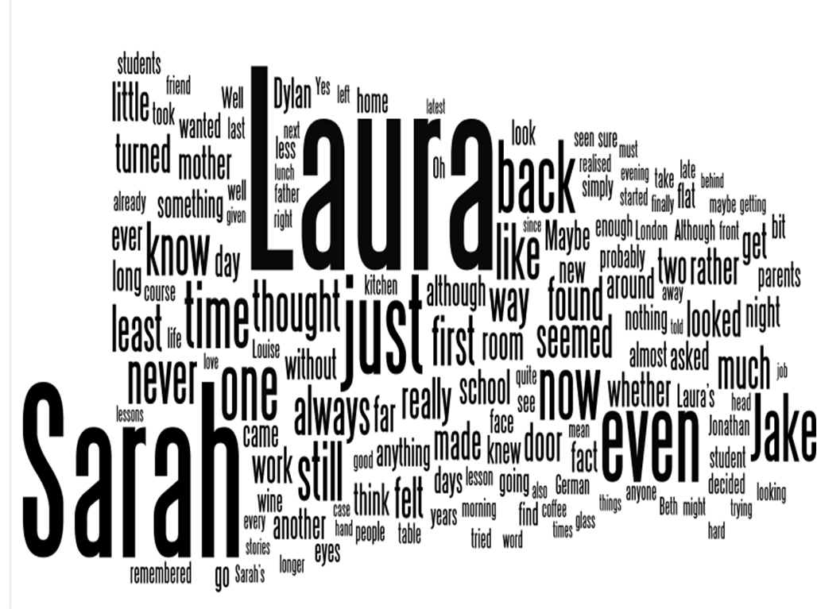

If you look at the word cloud, you will see that there is very little interesting apart from the names of the characters, which dominate. All I can find in there is mother, door and school. (Be aware that this is the word cloud for the whole work, not just the first 40 pages.) It’s only here to make you think about your work in a different way.

The following phrases occur too often in the text.
- Eight times
  - the fact that
- Five times
  - at the time
- Three times
  - in front of the television
- Twice
  - she had no idea why she had
  - came as a bit of a surprise
  - he really just wanted to catch up
  - when she arrived at the
  - she took a deep breath

Seems, seemingly, seemed, etc. occurs 25 times. That is 20 too many.

Nit Picking
The only way to deal with TUBE STRIKE, in my opinion, is to attack it on a sentence by sentence basis, then smooth it over on a full rewrite. Decide what kind of style appeals and work towards it. I think you should try to be more wordy, more intricate.

I promise you that these five sentences are wholly random.

No, I’m fine thanks.
- at first sight a perfectly harmless piece of prose, but when you consider that my main criticism of TUBE STRIKE is that it is boring and flat…

It felt cold and she couldn’t smell gas, but she still made sure that all four control buttons pointed to zero.
- was it cold or was it not cold? If it was cold, say It was cold.
- Minimise it if you like.
  - It was cold. There was no smell of gas. All four controls pointed to zero.
- Maximise it, as my preference
  - She touched the white enamel and her knuckles detected no warmth. She clutched her dressing gown around her and leant forward to sniff the burners. No smell of gas. She briefly turned on each of the control knobs and clunked them back off again. She stood back and looked at the stove: no heat, no smell, 0 0 0 0. She sniffed again, turning her head and looking at the stove from the corner of her eye. No heat, no smell. Back to bed.

Can’t keep them, can’t kill them – oh my God, I’m so sorry!
- at first sight a perfectly harmless piece of prose, but when you consider that my main criticism of TUBE STRIKE is that it is boring and flat…

Although Laura’s language school had premises in the City (which she hated), she often had to teach clients, especially merchant bankers, in their offices.
- parentheses, my oh my.
    - Laura hated the City, and despised the school’s premises there. In any case, most of her clients were merchant bankers who considered themselves too busy and important to come to her, so she found herself teaching in offices more frequently than classrooms.

But just as she was beginning to drift off, she remembered the television.
- people don’t just begin to drift off, they drift off.
    - Drifting off, she remembered the television and came abruptly back.

You are going to have to work on every sentence: each and every one.

Summary
There is no doubt that there is some real talent here, but I am not really interested in what happens to Sarah and Laura. Things need to move more smartly long and if you insist on giving us so much of your characters’ backgrounds, then take us back there and give it to us live. There is no reason why you should not be aiming at 400 pages rather than 120.
- Take stylistics risks
- Get rid of parentheses and hyphens
- Change the characters’ names and nationalities
- Delete the pretentious literary allusions
- Actually show us these events from the past, maybe even using the present tense.

Advice about Advice
There is no point in getting worked up about advice which you don’t like. If you don’t like th advice that I have given, then don’t take it. There is a vast variety and range of tastes in the world, but almost no one likes bad writing. If you feel it is important to describe the hair styles of your characters in great detail, go right ahead, but before you do, at least consider the alternatives. Rejecting advice is just as important as accepting it.

Producing literature is not just ‘typing’ as Truman Capote would have said. It is a peculiar mix of letting your talent and sensibilities run wild, and then reining them in and putting them under control. The principal problem of TUBE STRIKE is that it lacks ambition and arrogance. Let yourself really go, lose control and then reassert control where necessary.
Gatsby’s Word Cloud, for comparison.

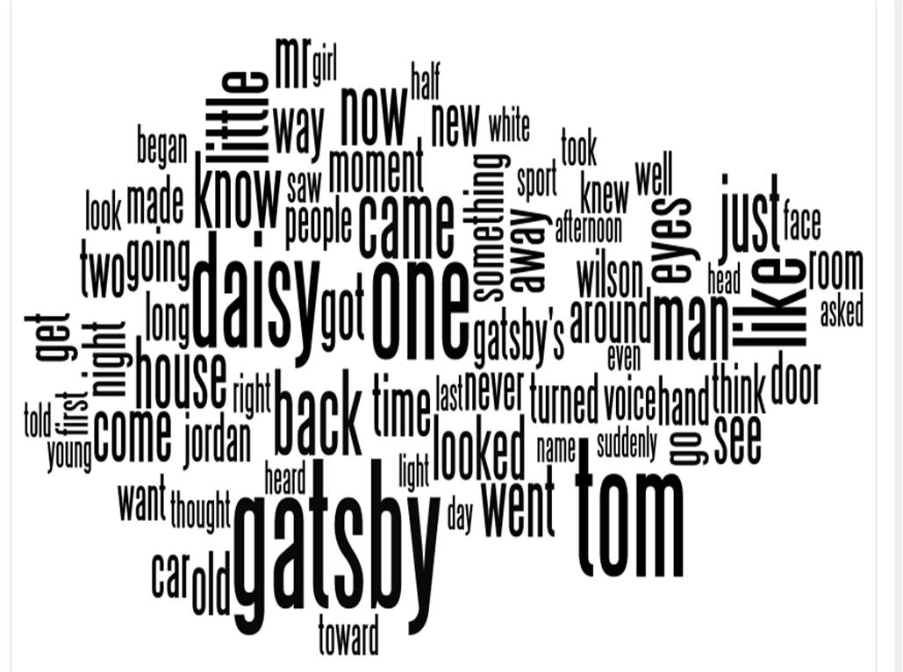http://www.wordle.net

